LAB EXAMINATION

NAME: SOUMYADIP GHOSH

STREAM: CSE-A

ROLL NUMBER: 1951007

AUTONOMY ROLL NUMBER: 12619001158

REGISTRATION NUMBER: 028830

SUBJECT: MICROPROCESSORS LAB

SUBJECT CODE: AEIE 2255

DATE: 23.09.21

GROUP: 1

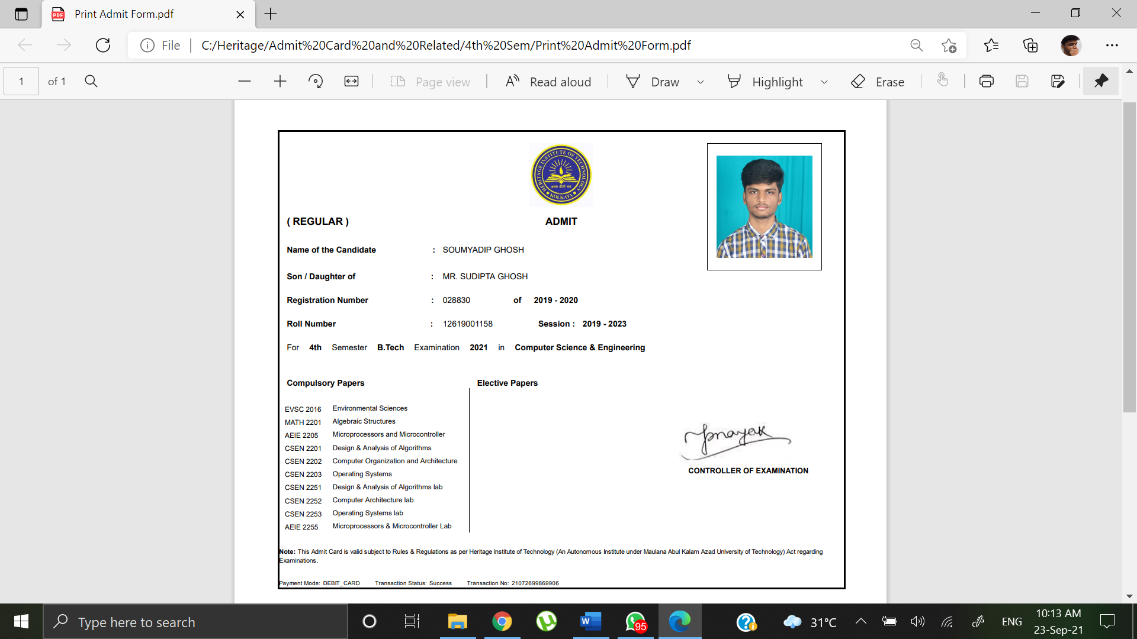

INTERFACING DIAGRAM OF 8051 MICROCONTROLLER

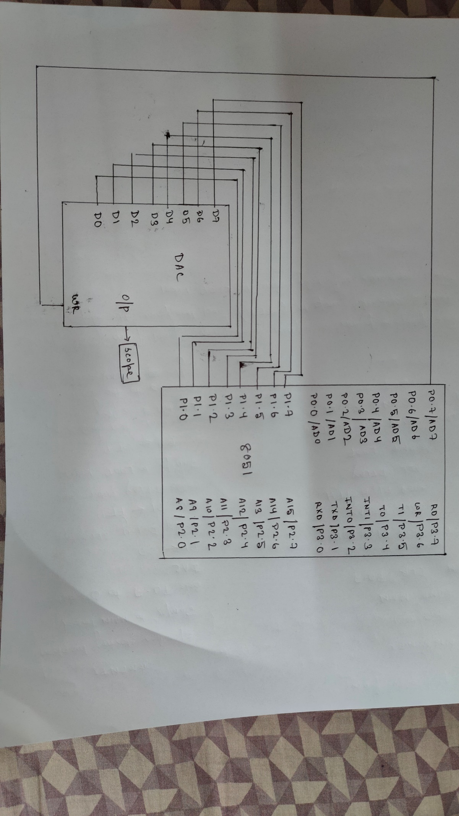

Question 1:

Set 7:

Microcontroller 8051 is interfaced with DAC. Write two different ALP to trace a saw tooth and square wave on scope using EDSIM51 simulator. Draw interfacing diagram.

Sawtooth:

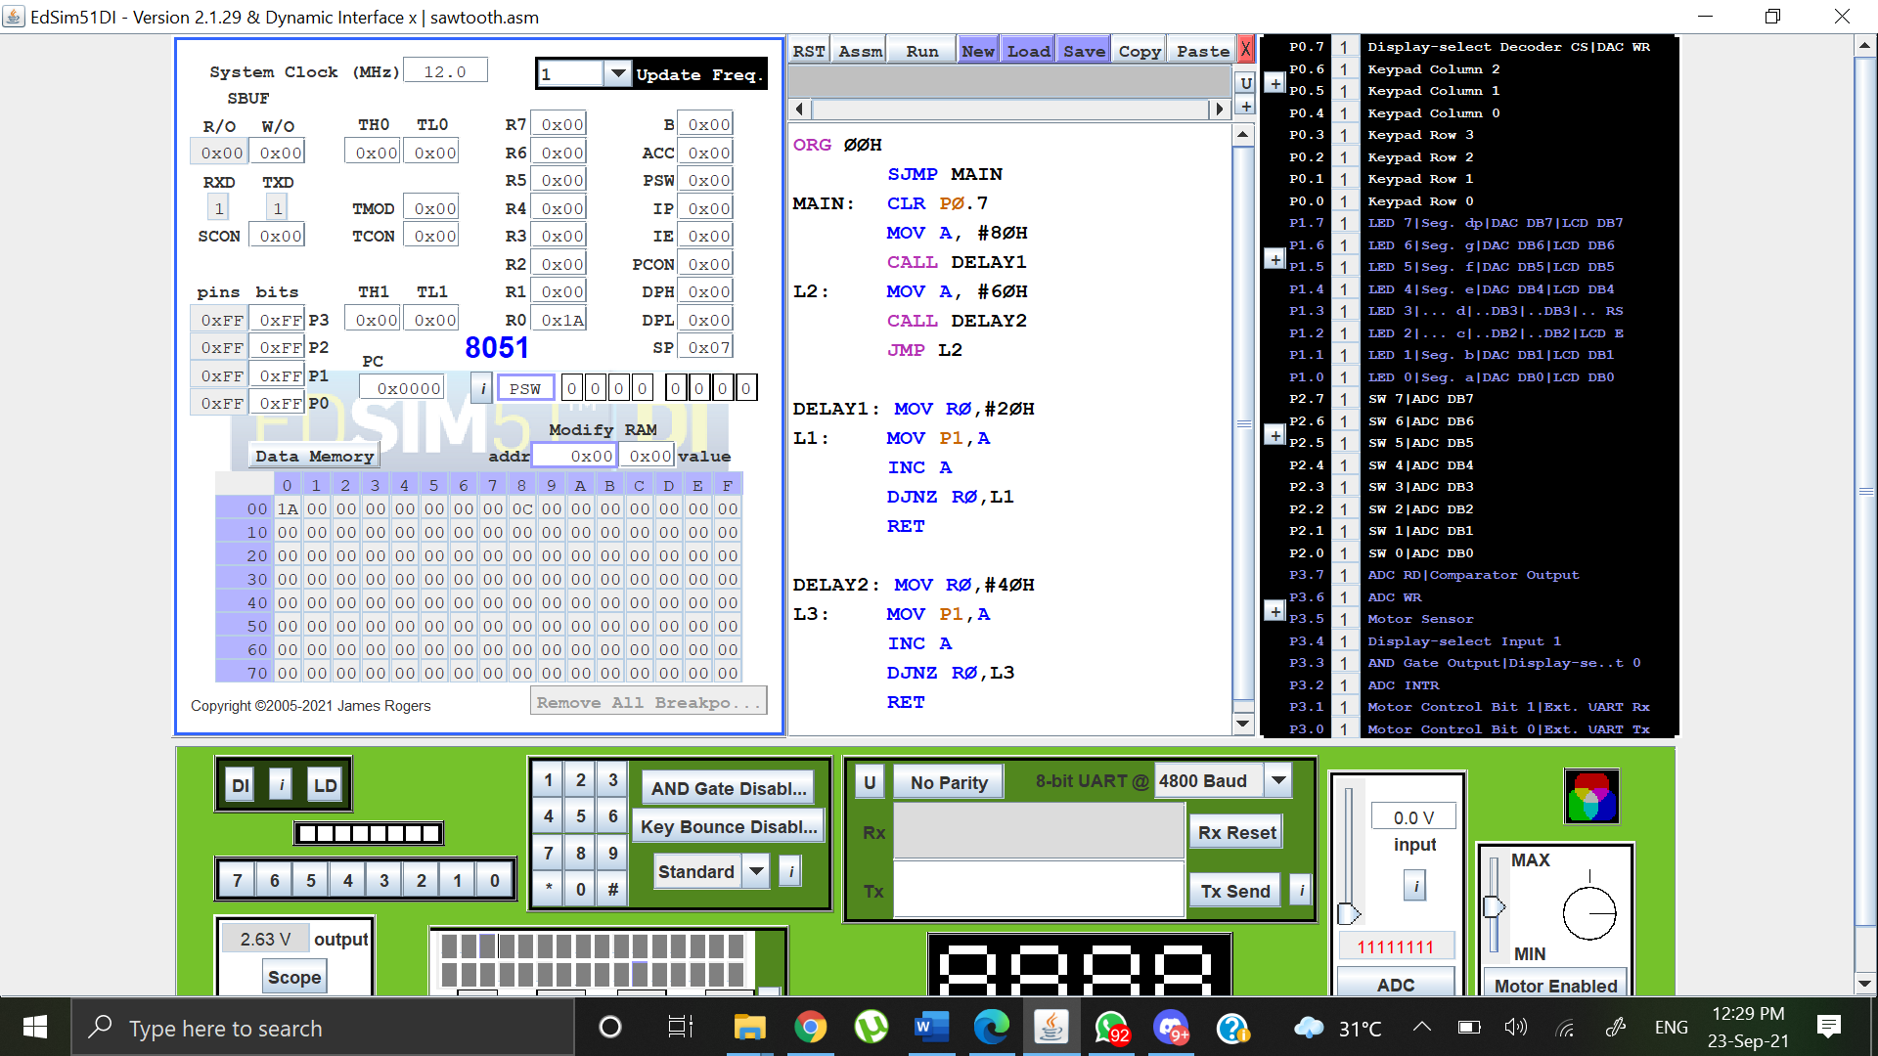

Output:

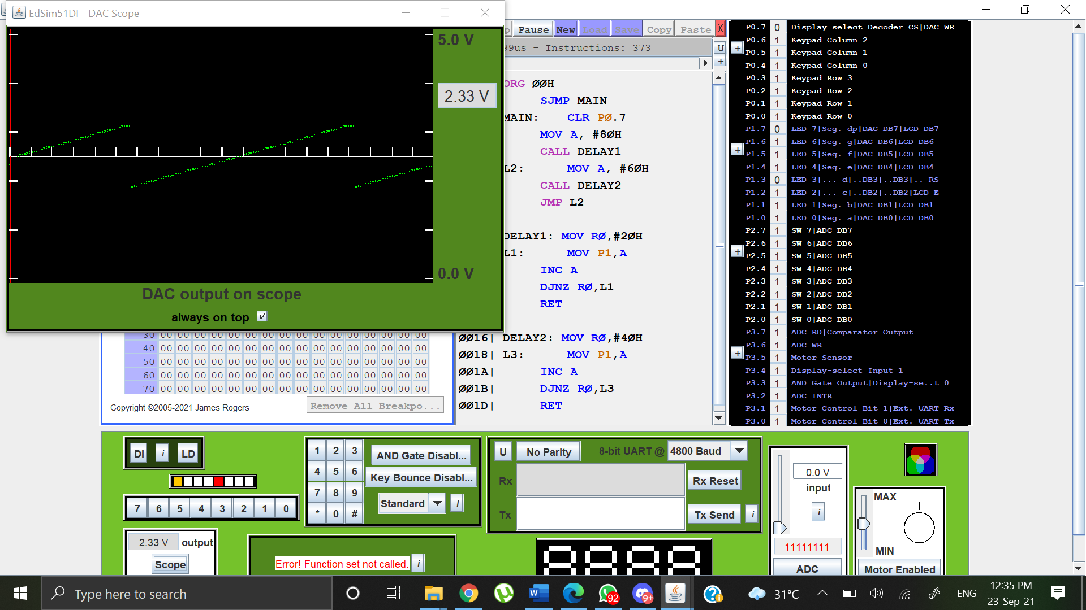

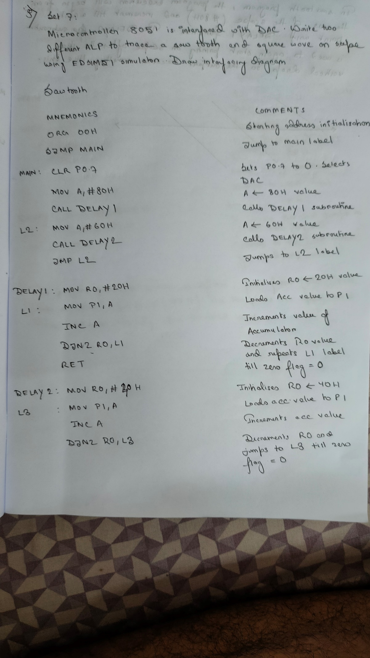

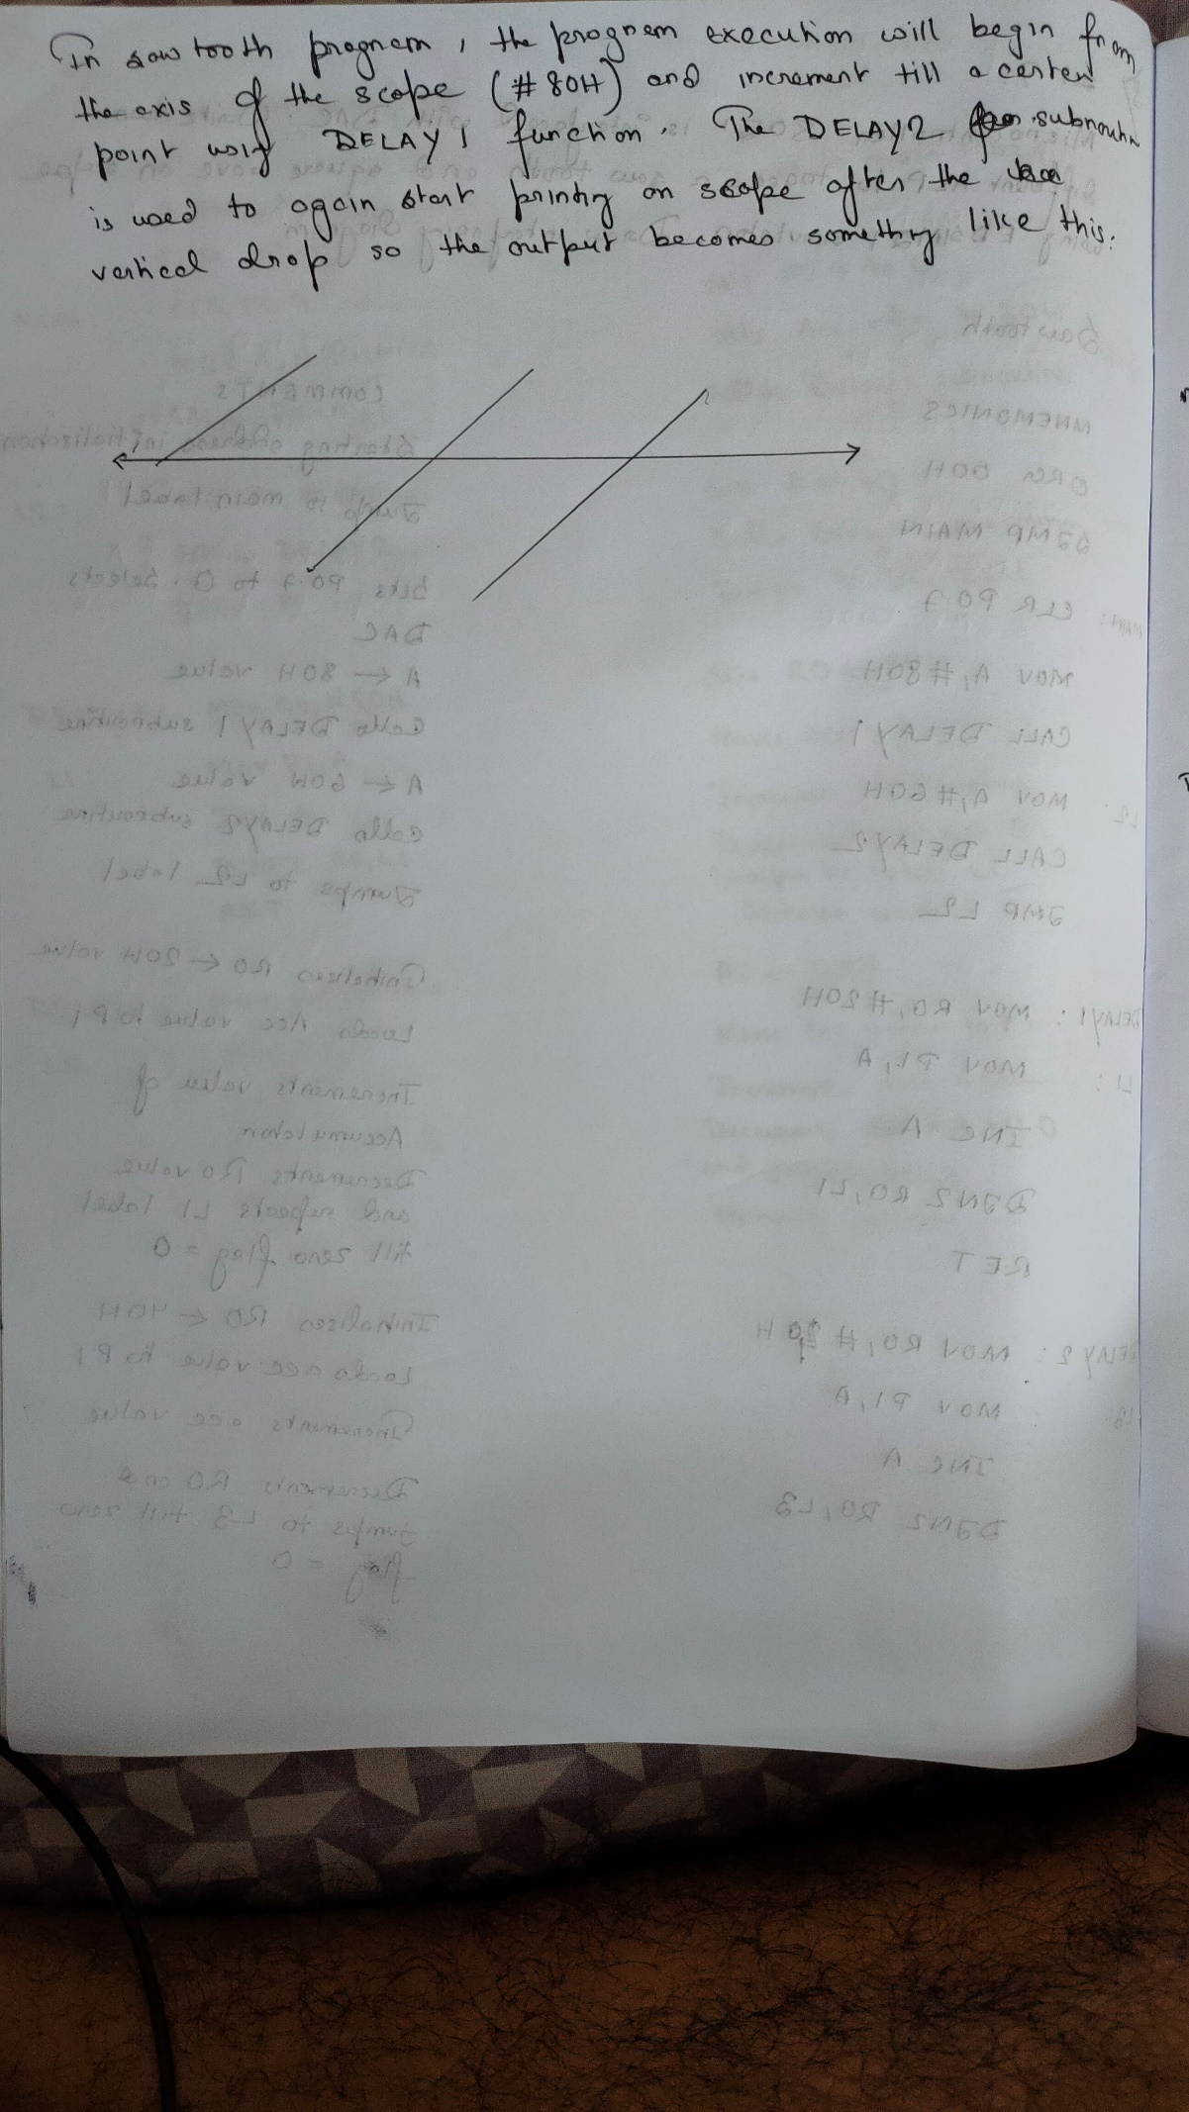

Square Wave:

Code:

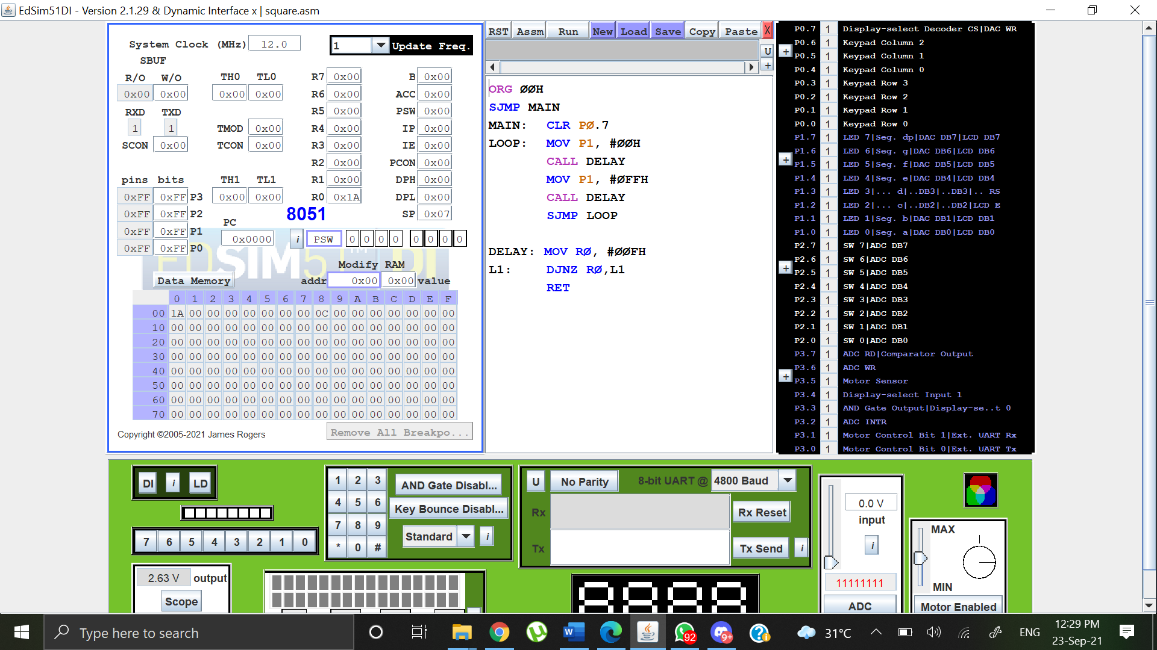

Output:

